**Flashcard User Guide**

**TEAM 6**

1. Joshua Folken
2. Vrusha Patel
3. Steve Thao
4. Melkam Getachew

**Table of Contents**

Contents ………………………………………………………………………………………………………………………… Page

1. Introduction ……………………………………………………………………………………………………………..3
2. Getting started…………………………………………………………………………………………………………. 4

2.1 Creating account ……………………………………………………………………………………………….. 4

2.2 Login to your account ……………………………………………………………………………………….. 7

3. Systems Requirement …………………………………………………………………………………………….. 8

4. Main scenario of use ………………………………………………………………………………………………… 9

4.1 Create Flashcard ……………………………………………………………………………………………… 9

4.2 Study Flashcard ……………………………………………………………………………………………… 12

4.3 See Report Card …………………………………………………………………………………………….. 15

4.4 Edit Flash Card ………………………………………………………………………………………………...16

4.4.1 Edit your flashcard …………………………………………………………………………….16

4.4.2 Edit Public flashcard …………………………………………………………………………. 18

5. Troubleshooting ………………………………………………………………………………………………………….. 20

5.1 Locked account ………………………………………………………………………………………………. 20

5.2 Error when creating a new flashcard ……………………………………………………………… 20

# Introduction

Flash cards are a useful tool for learning faster and reviewing for exams. This flashcard application allows users to create and study virtually. It allows anyone to create an account and create sets of flashcards for studying. Users can share flashcard. When creating a flashcard, the user can make it public or private. Public flashcards can be viewed by all the users of the app, while private flashcards can only be seen by the creator. When a user studies with a set of flash cards, it will allow the user to guess what is on the other side before revealing the answer. It will also prepare a report card to give a feedback on the user’s performance overtime. A user can edit public flashcard and make it their own without affecting the original set. This document will provide instructions on how to use the application.

**2. Getting started**

**2.1 Creating account**

Go to the website <http://localhost:56392/Login.aspx>

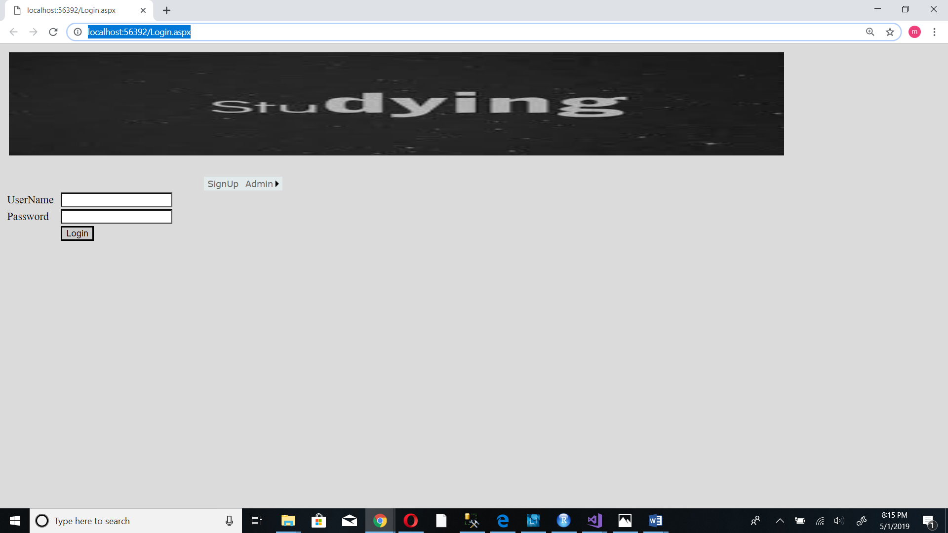

1. The login screen will be brought up

2. Tap the SignUp button

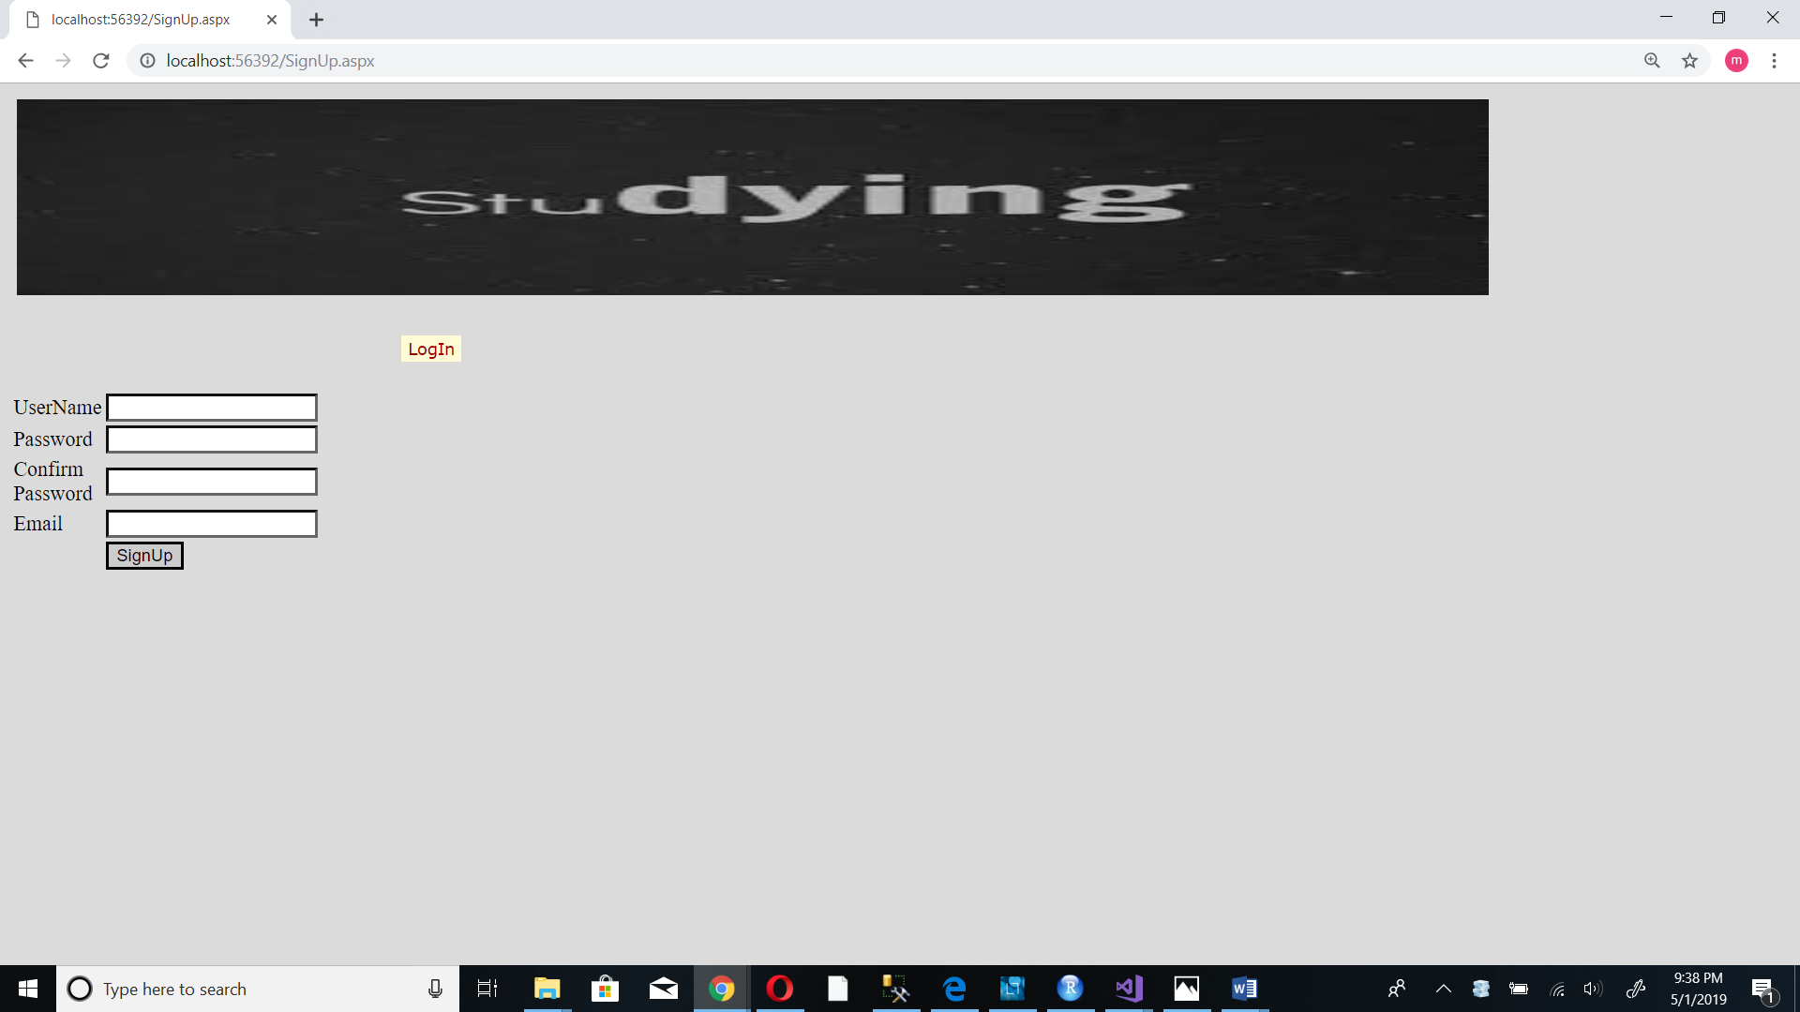

3. Fill in all the required information

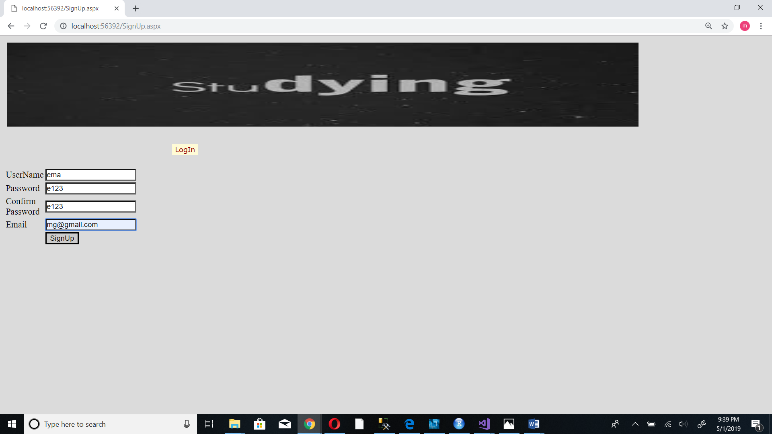

Password – should be at least 4 in length. Should include at least one character and one digit.

4. Tap the SignUp button to create an account

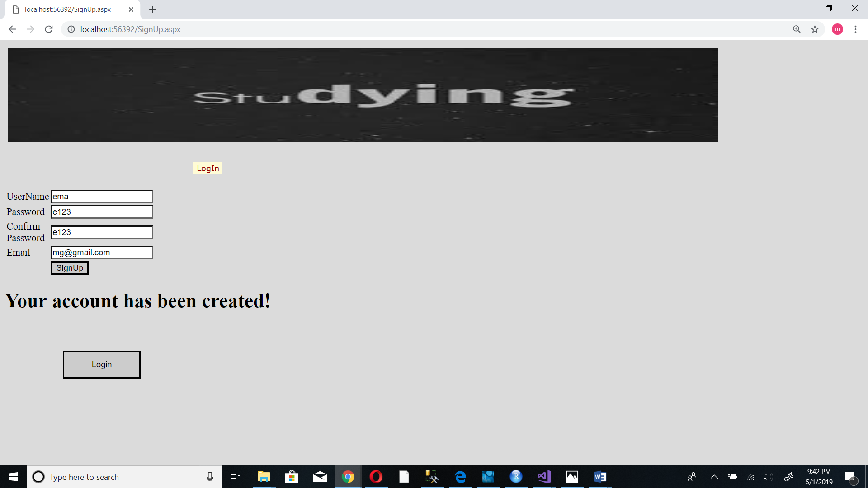

5. Tap the Login button to log in to your account

**2.2 Login to your account**

Go to the website <http://localhost:56392/Login.aspx>



1. The login screen will be brought up
2. Enter your user name and password

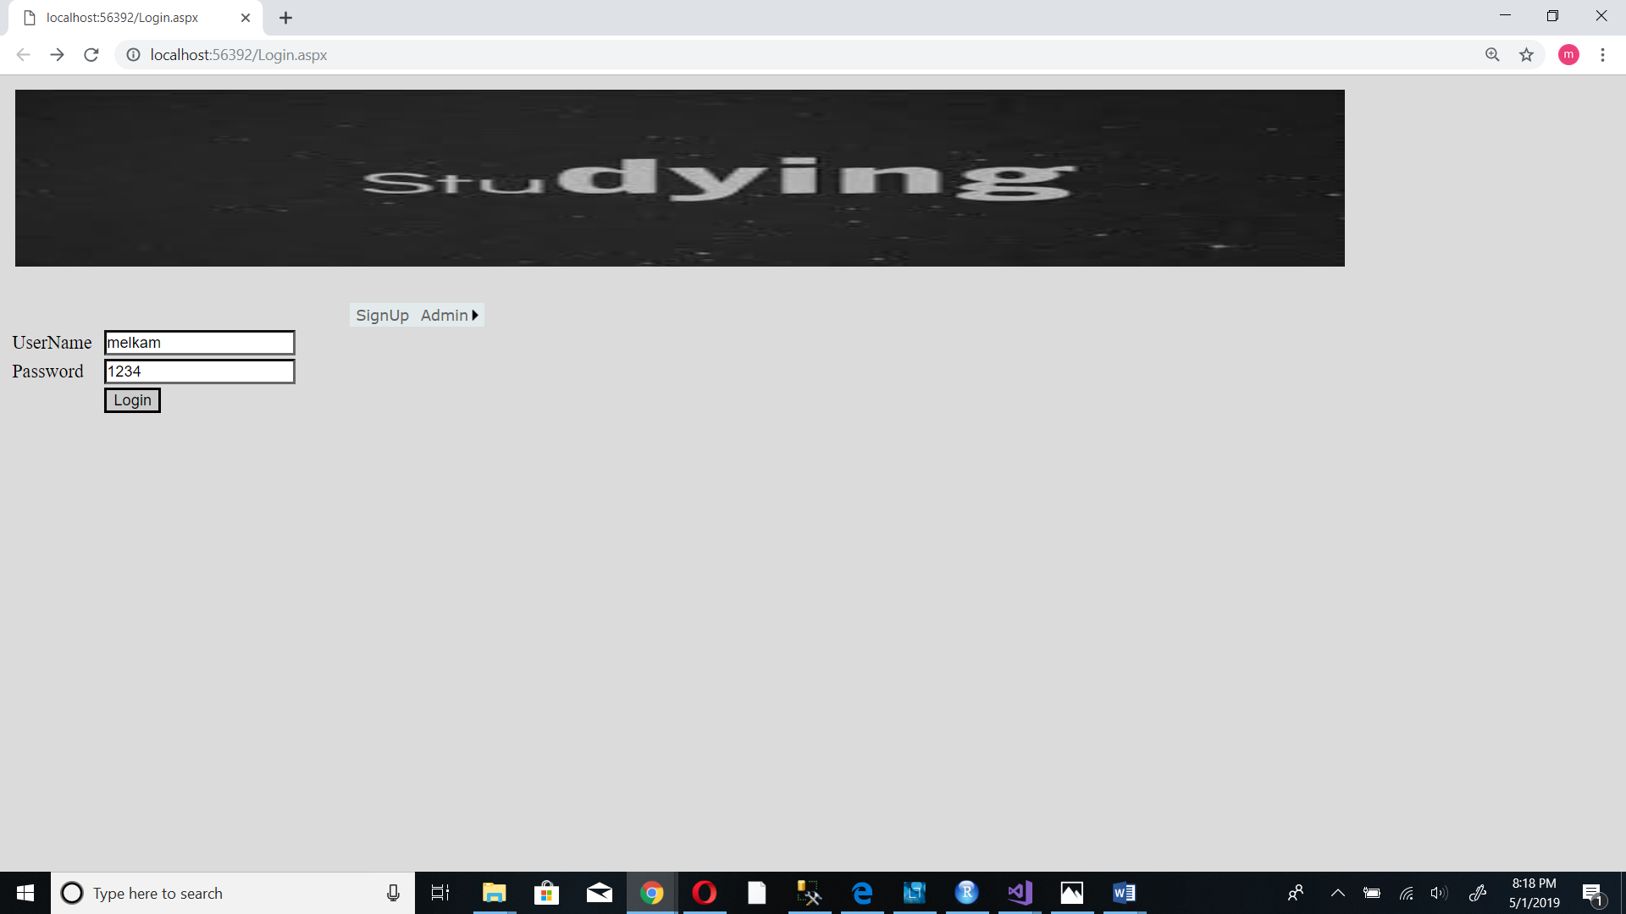

1. Tap the Login button
2. You will be redirected to your home page.

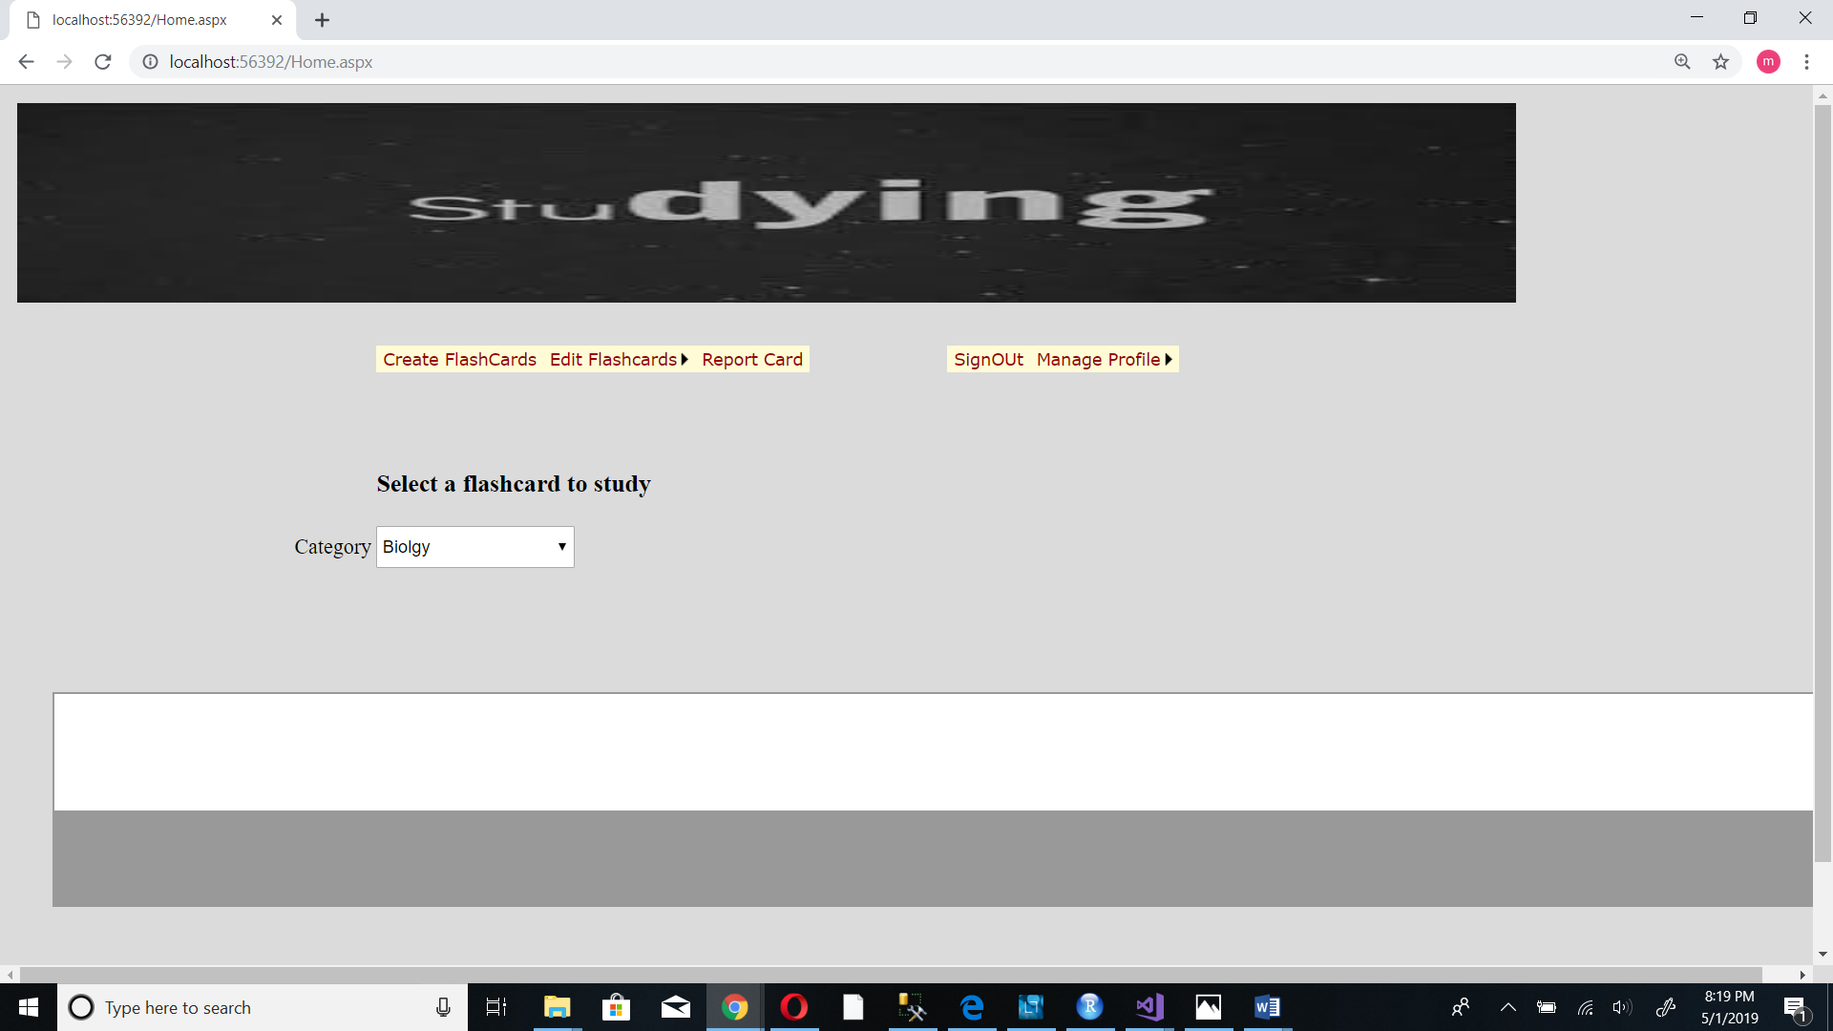

1. **System Requirements**

Personal computer

Windows mobile smart phone

**4. Main scenario of use**

**4.1 Create Flashcard**

1. From the home page Tap create Flashcards button

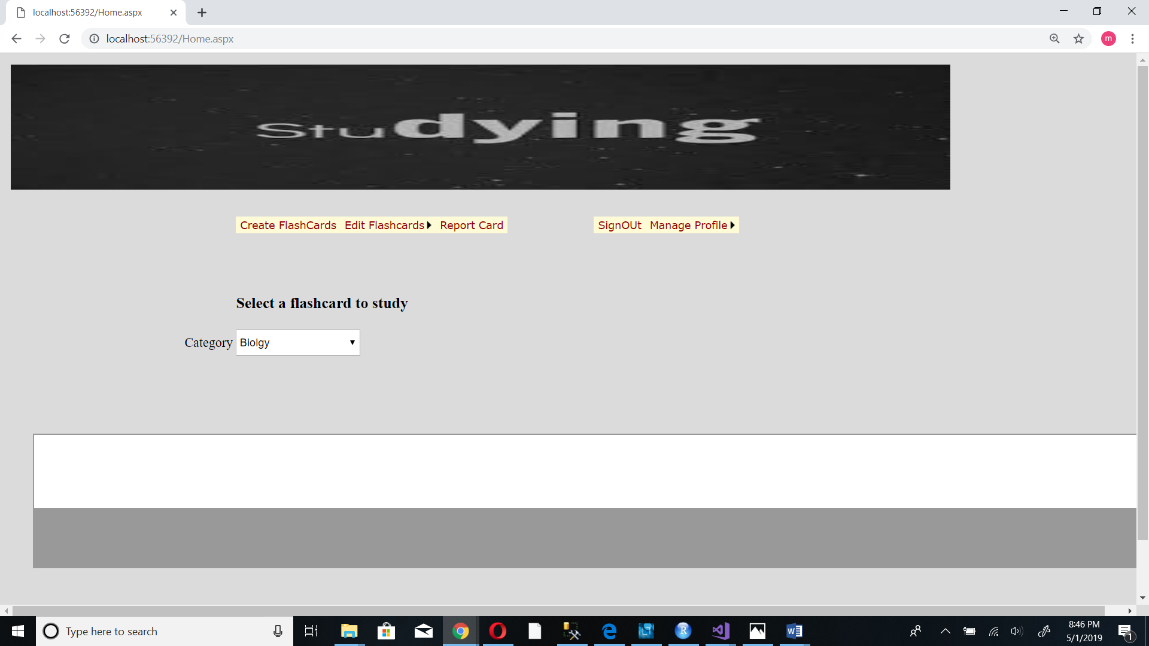

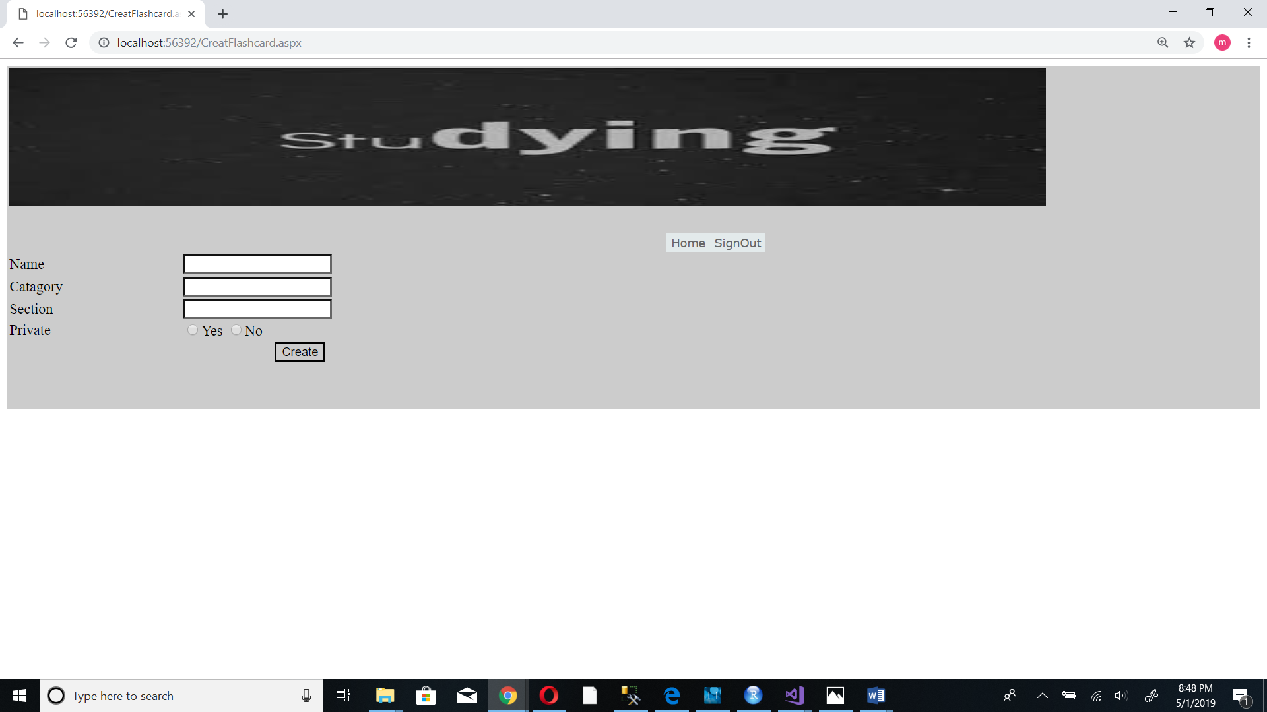

2. Enter information of the flashcard

Name - Name of the flashcard

Category – category of the flashcard that is Biology, physics, C++ ….

Section – Specific area of the subject that is cell, velocity, class, function….

Private - whether you want to share your flashcard with others or not

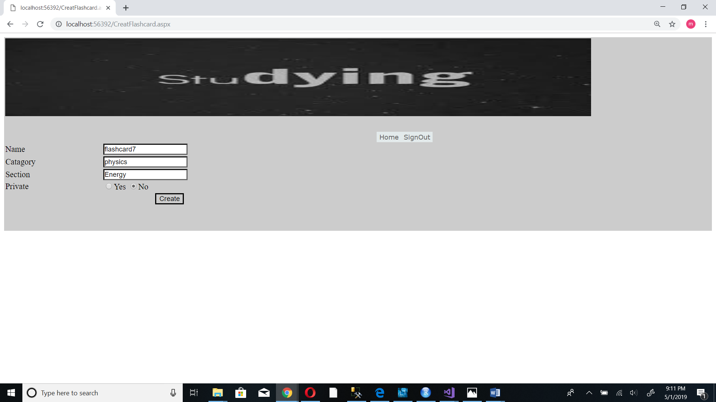

3. Tap the create button

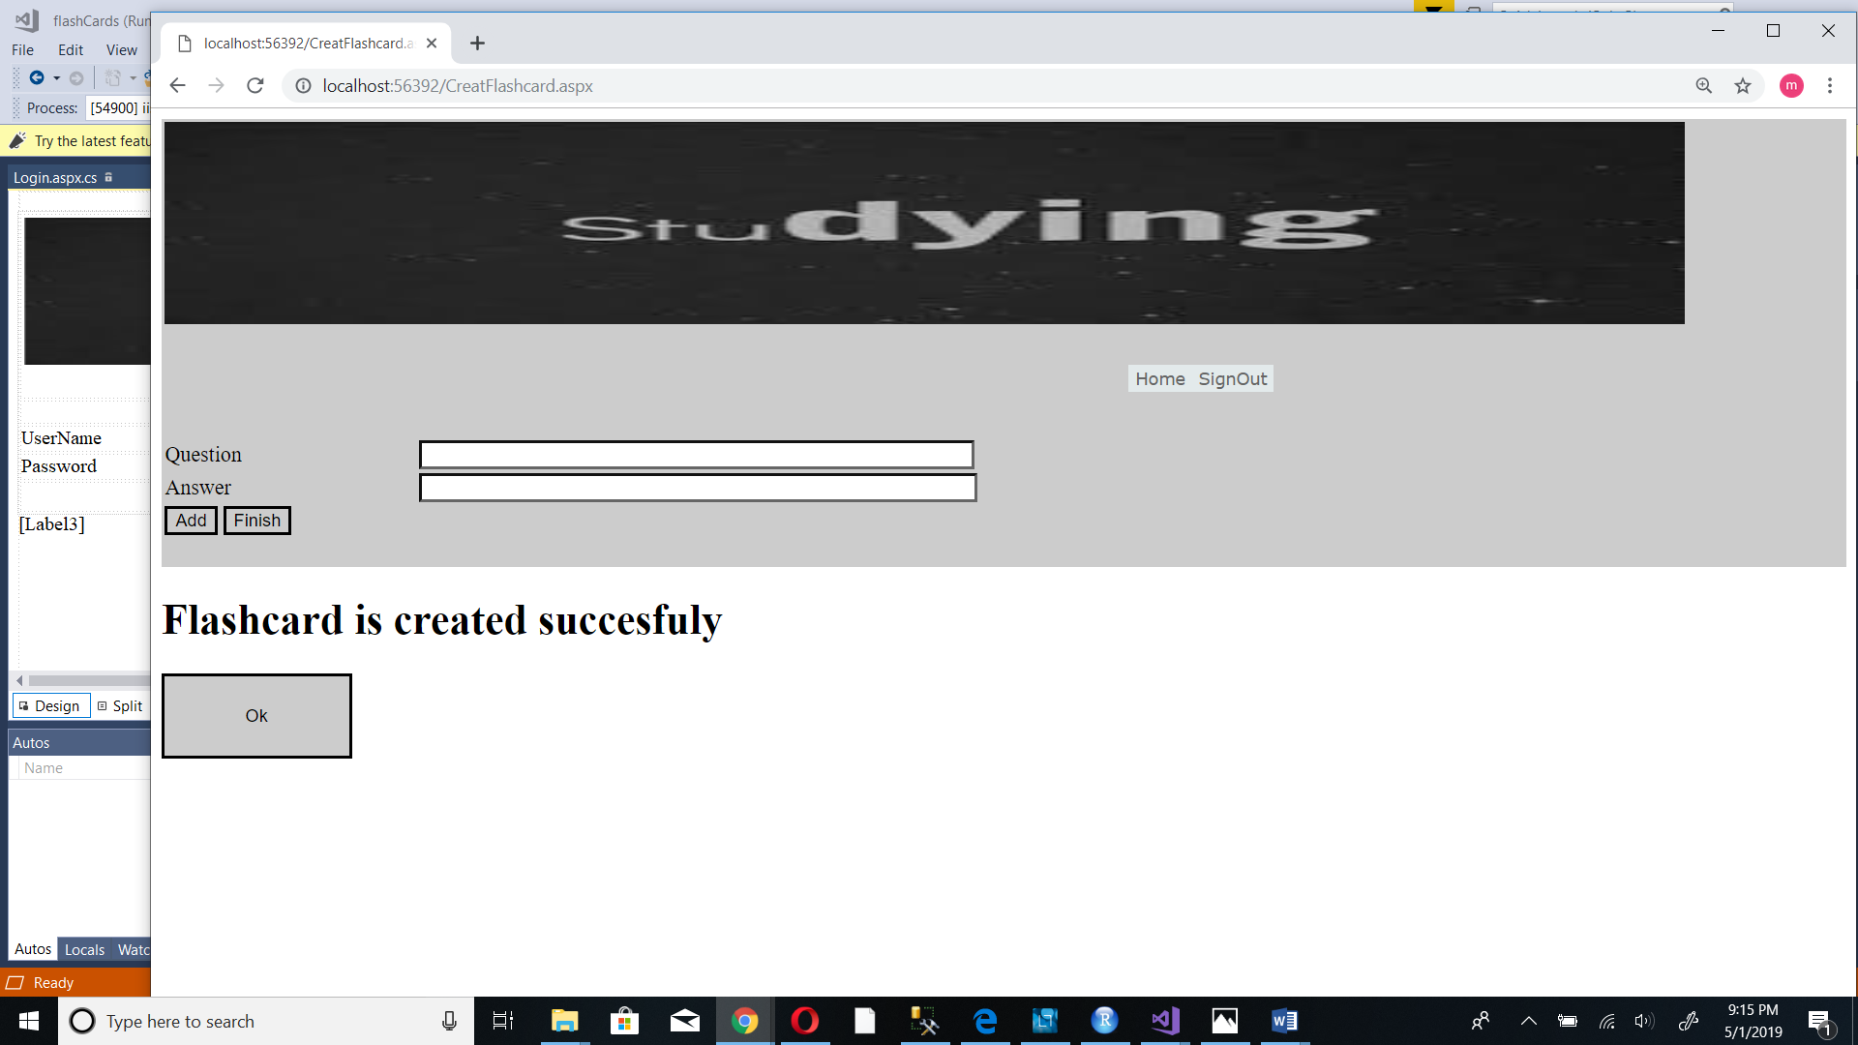

4.Type Question and answer

Tap the add button to add the question and the answer to the flashcard

Repeat these steps to add more questions and answers to the set

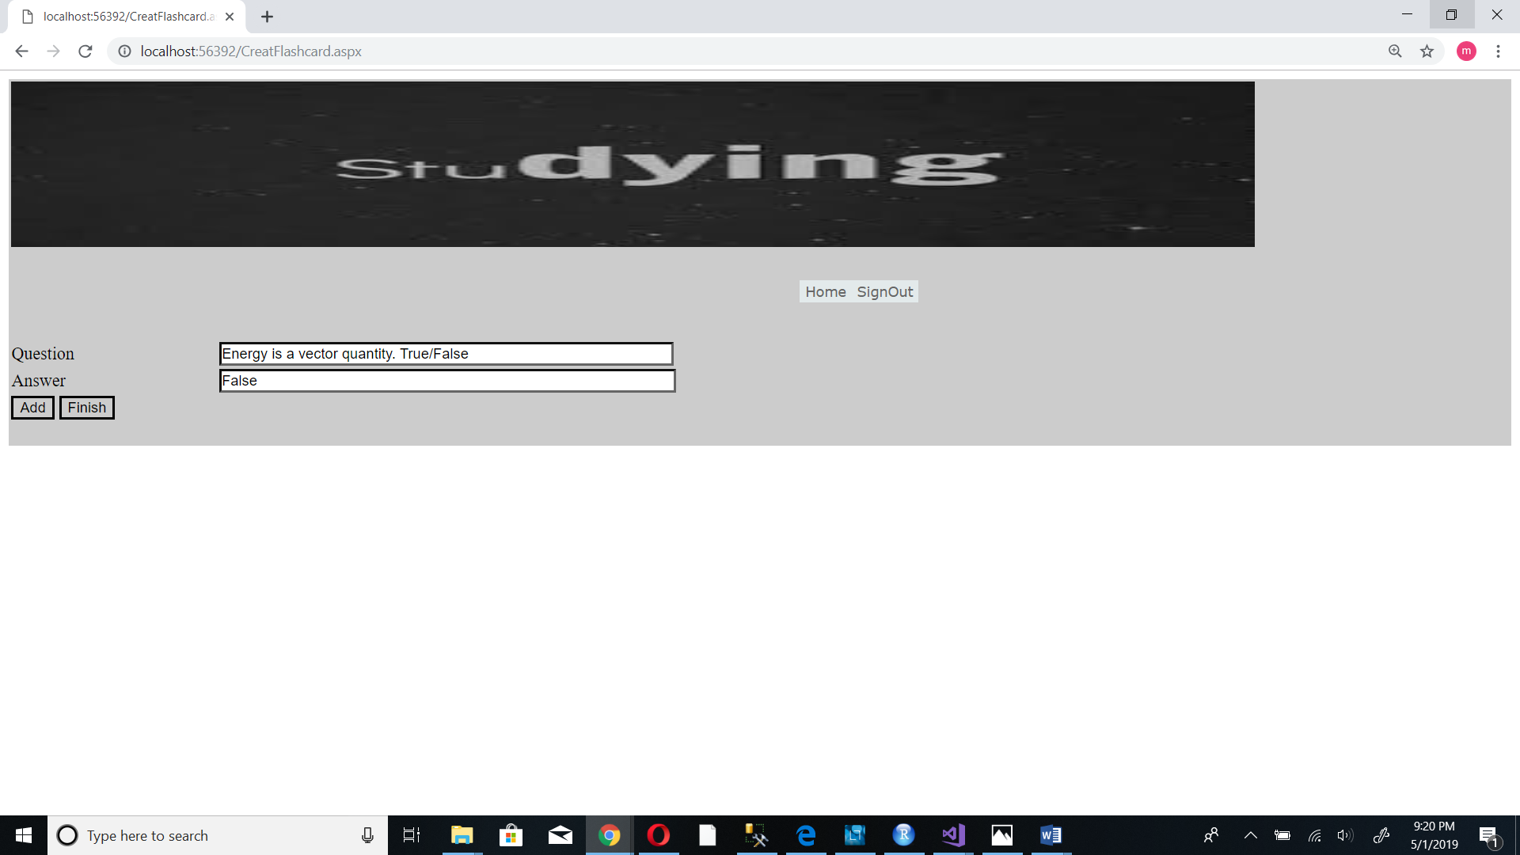

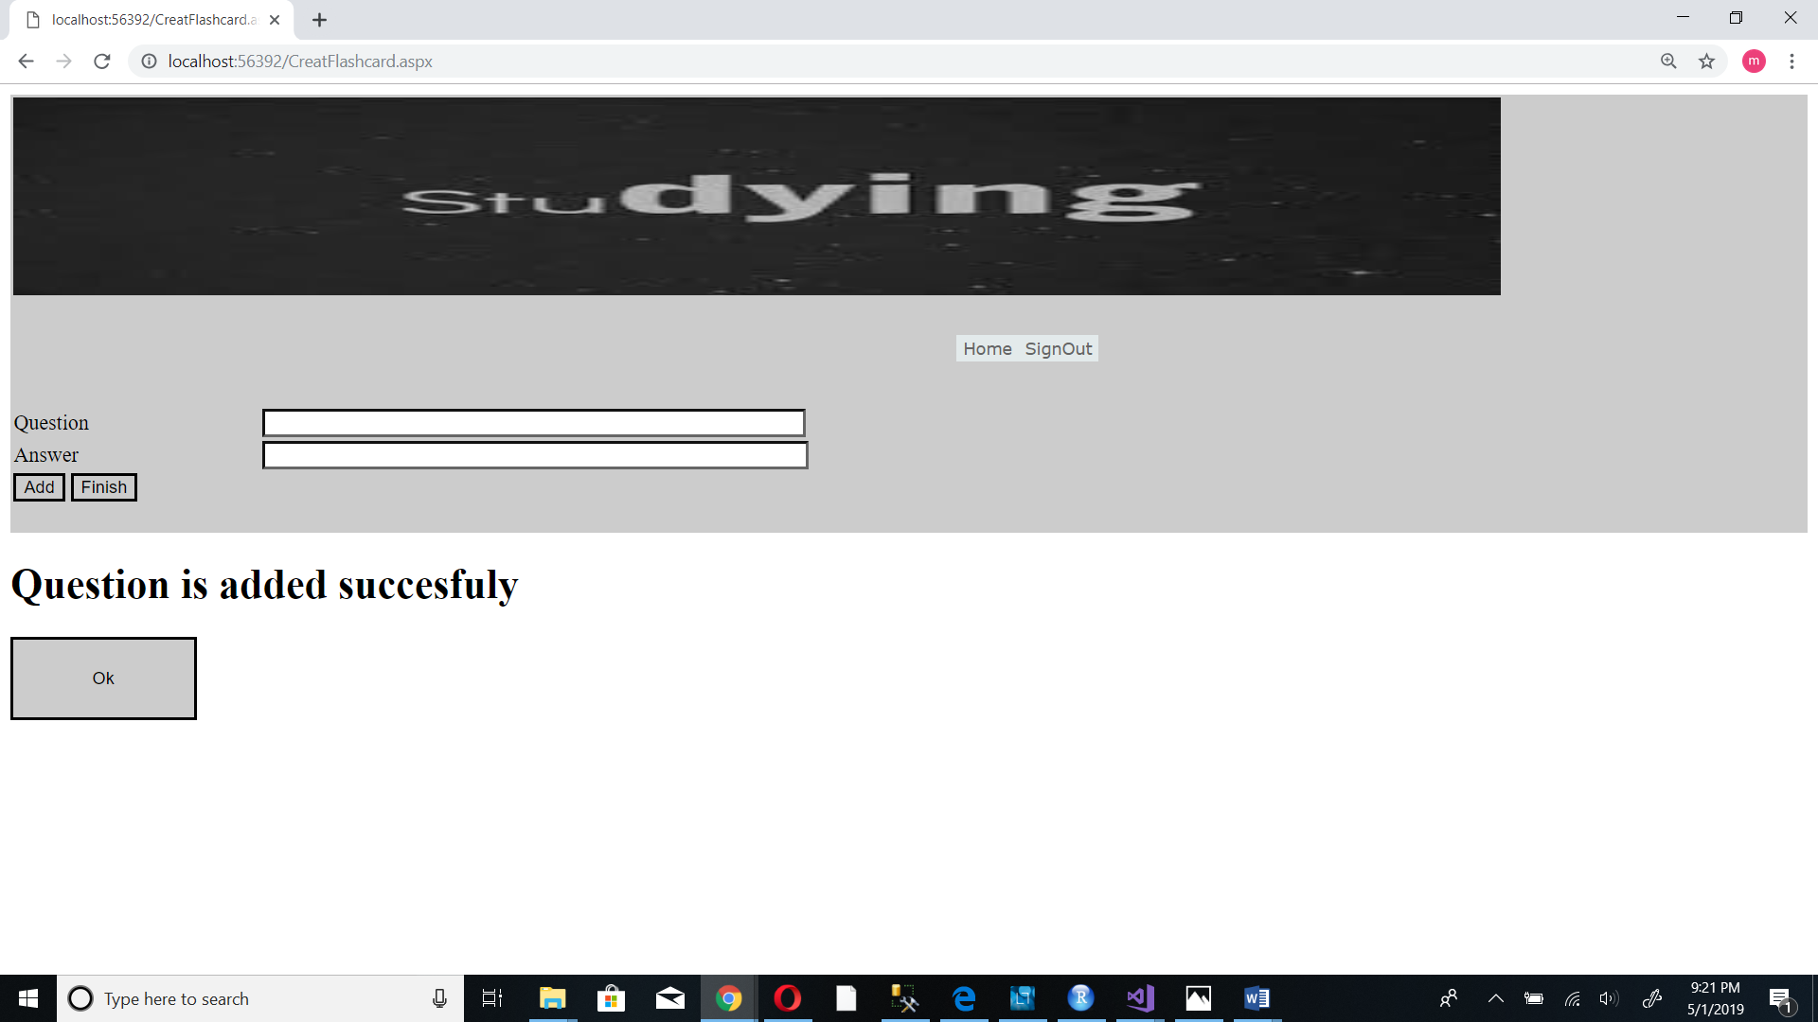

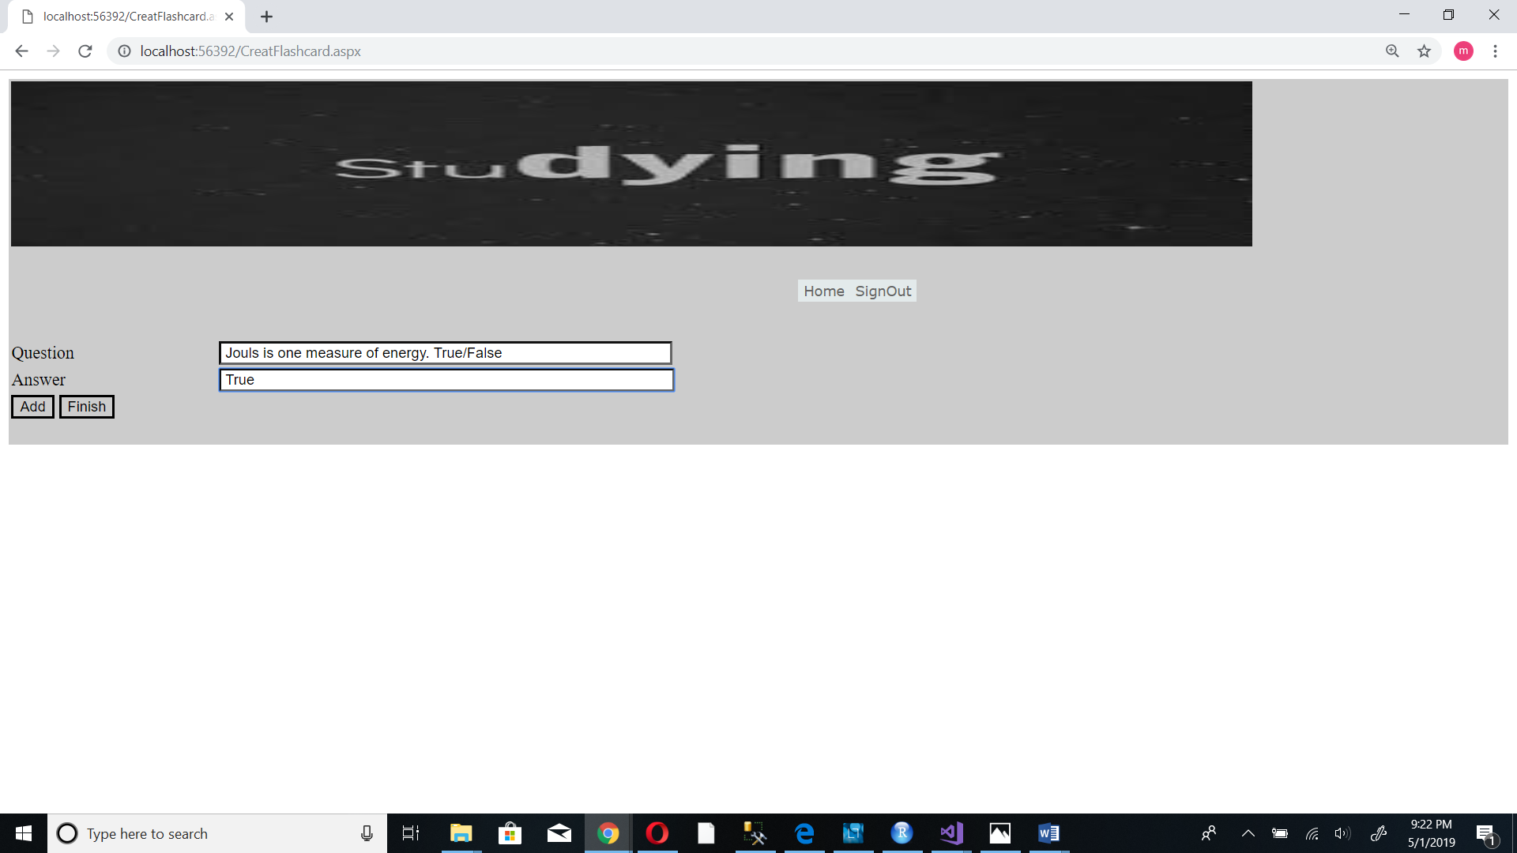

1. Tap the finish button to finish adding questions. You will be redirected to your home page.

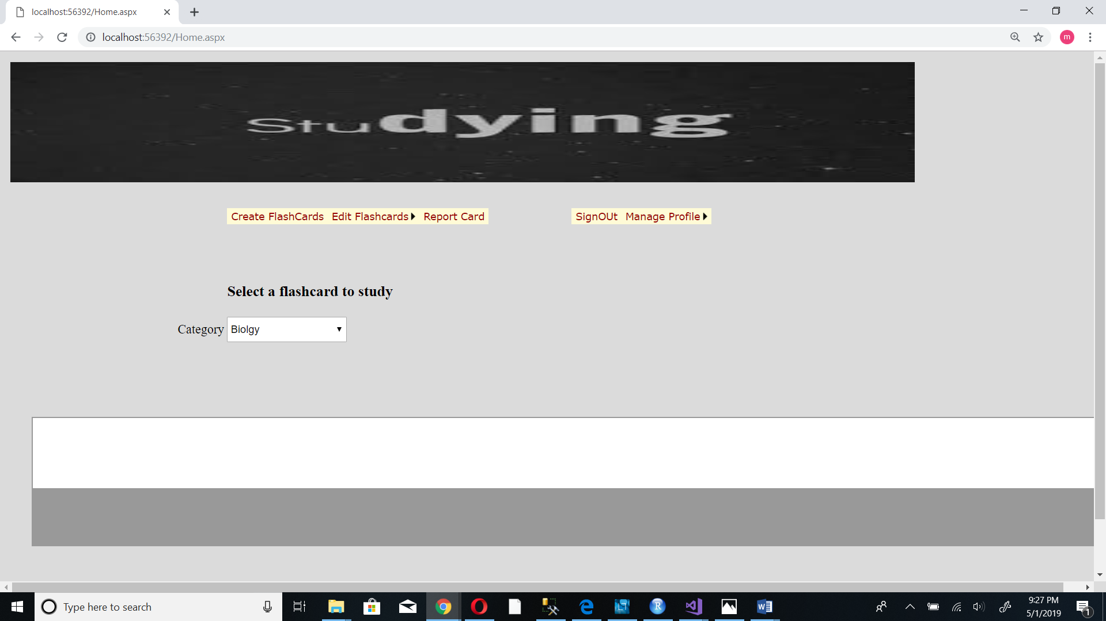

**4.2 Study a flashcard**

1. From your home page select the category of flash card that you want to study

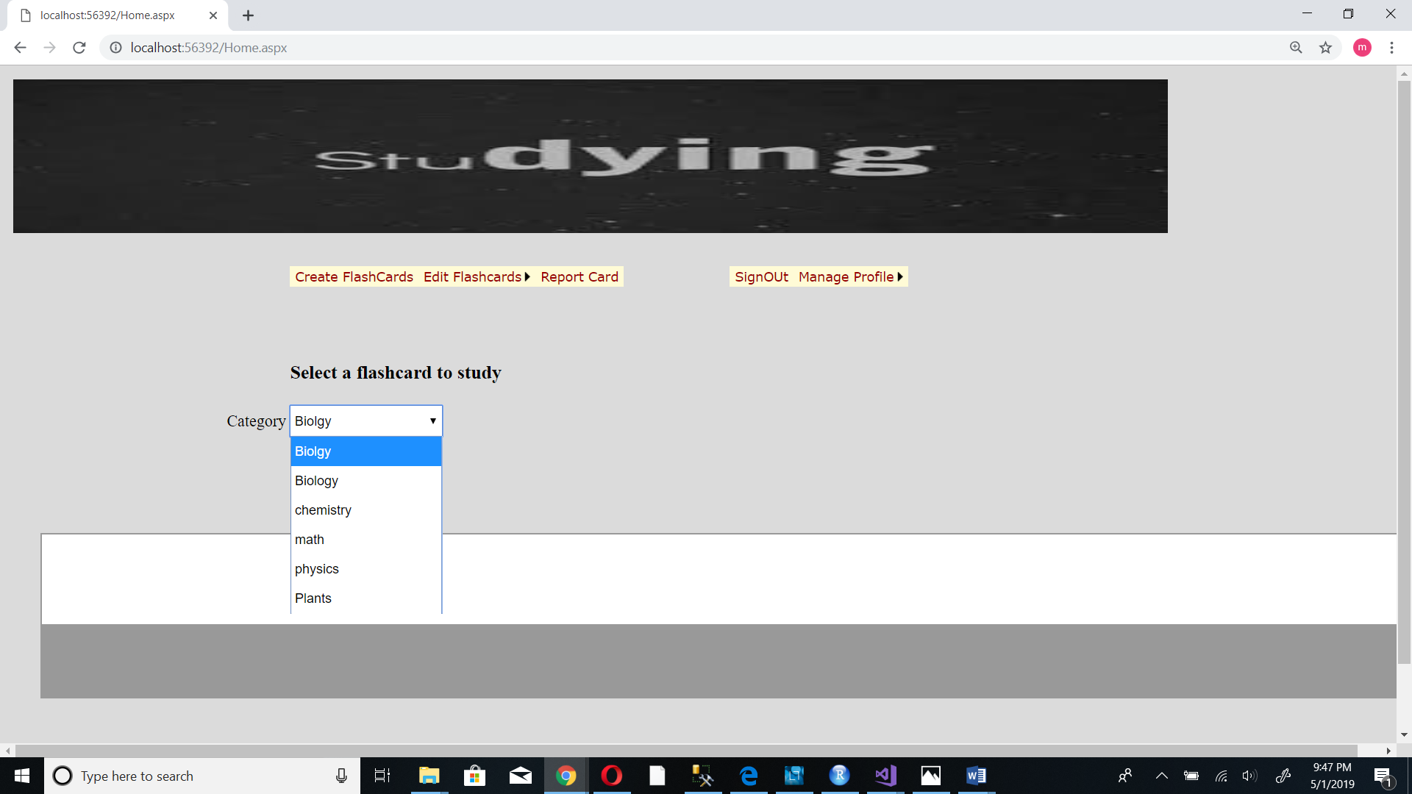

2. Select the specific flashcard you want to study

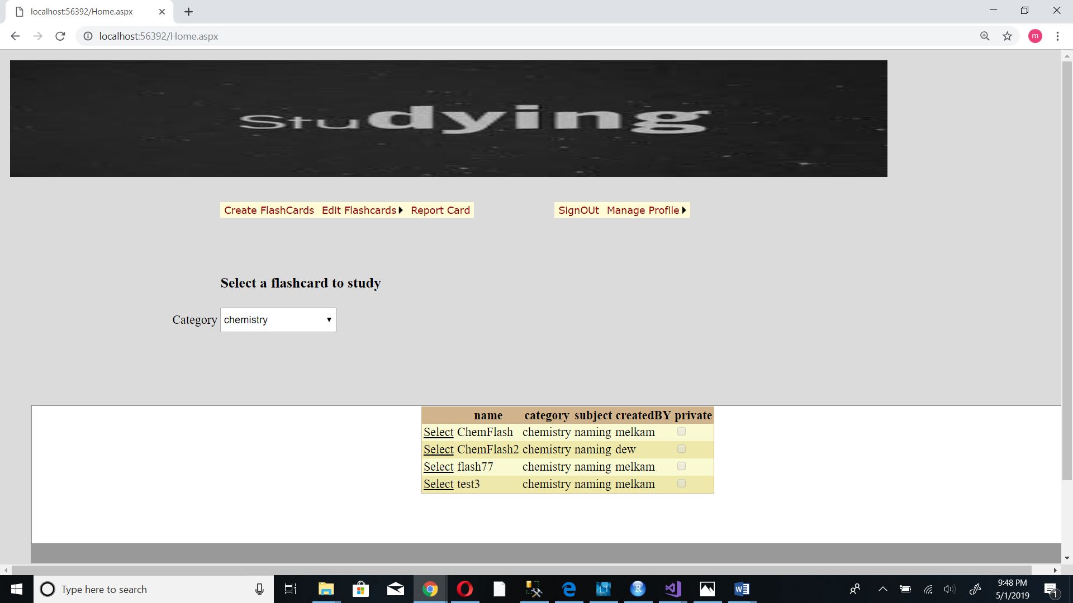

You will be redirected to the question and answers page

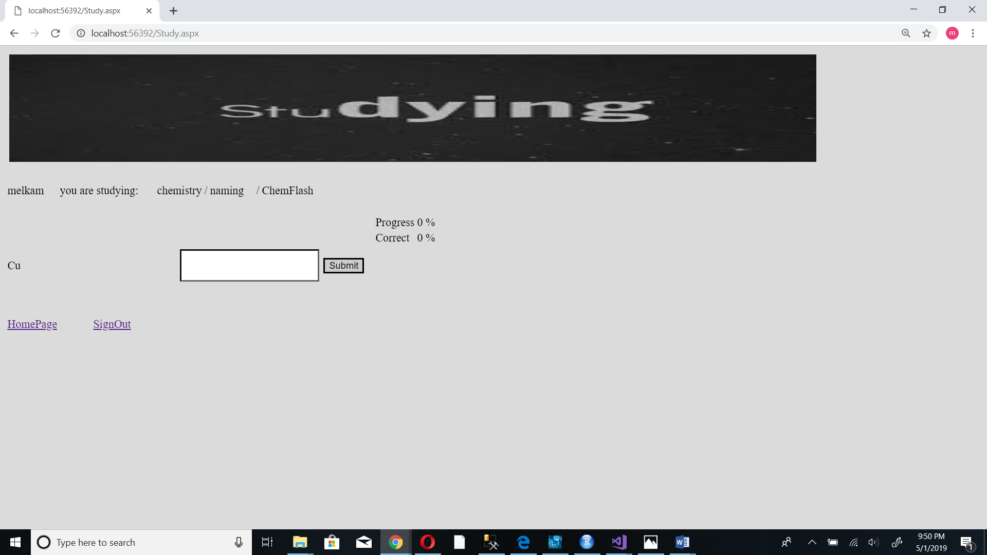

3. Provide answer to the question and tap the submit button

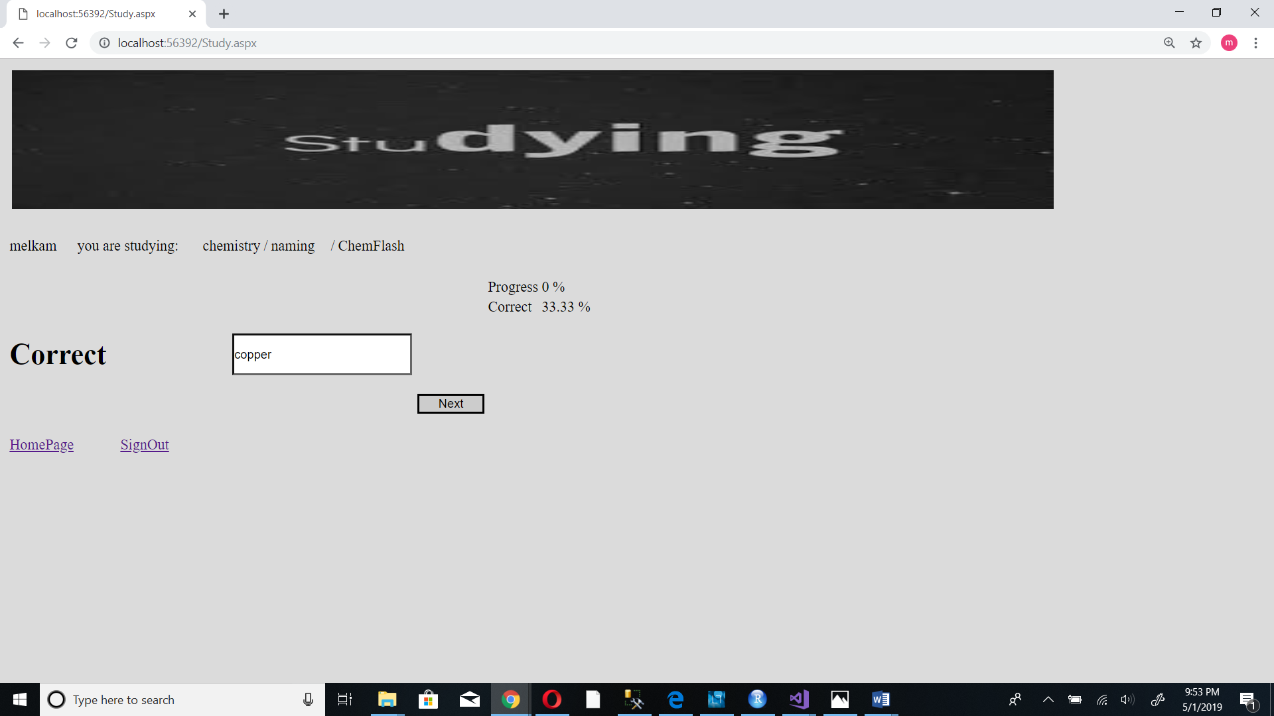

4. Tap the next button to go to the next question

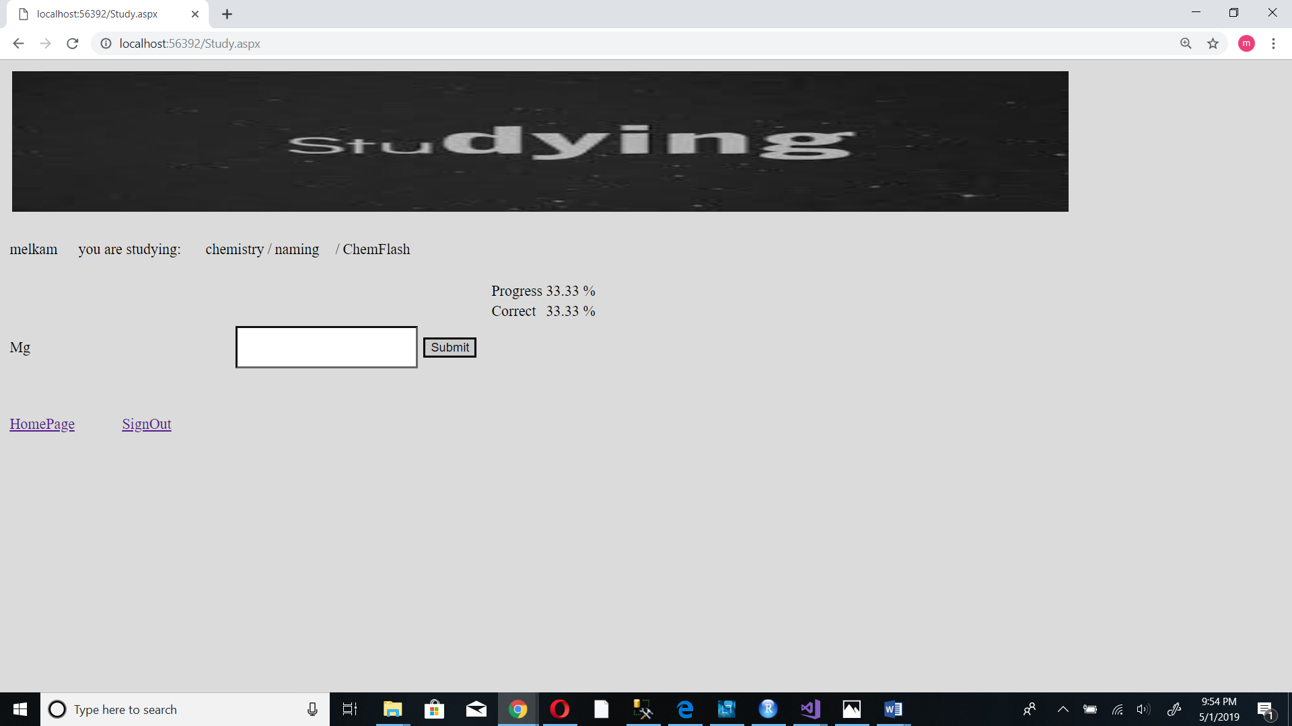

5.Repeat the step 3 and 4 until all the questions in the set are finished

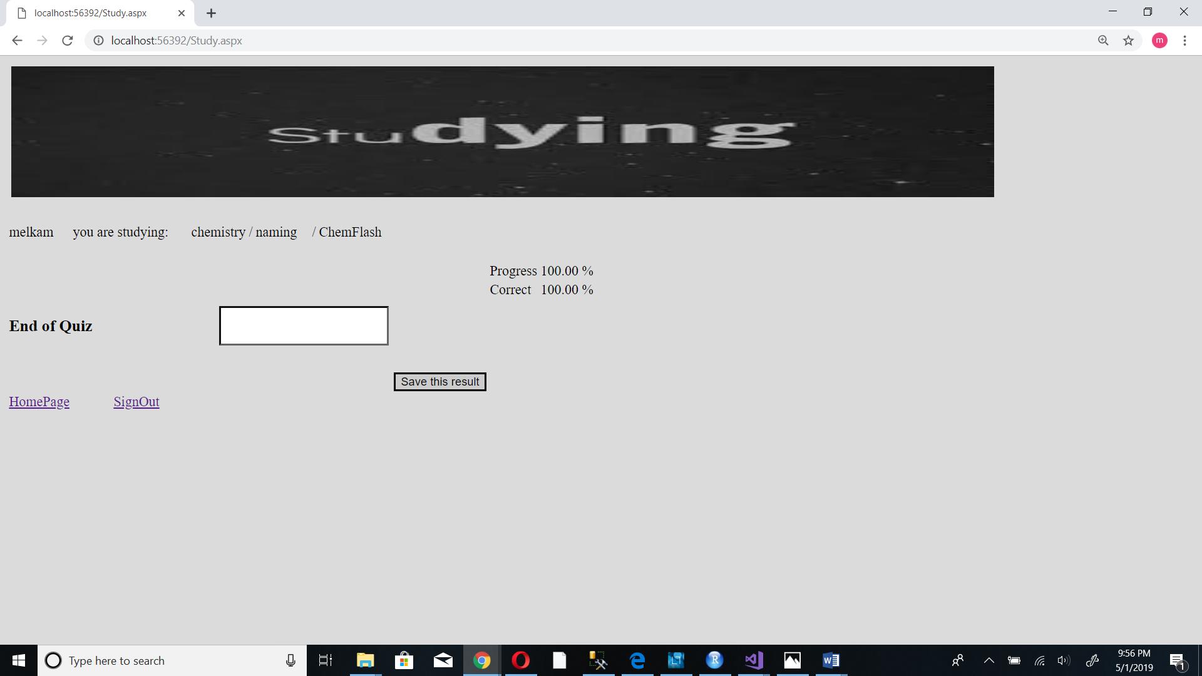

1. Tap “save this result” button to save your result or tap Homepage link if you don’t want to save your results

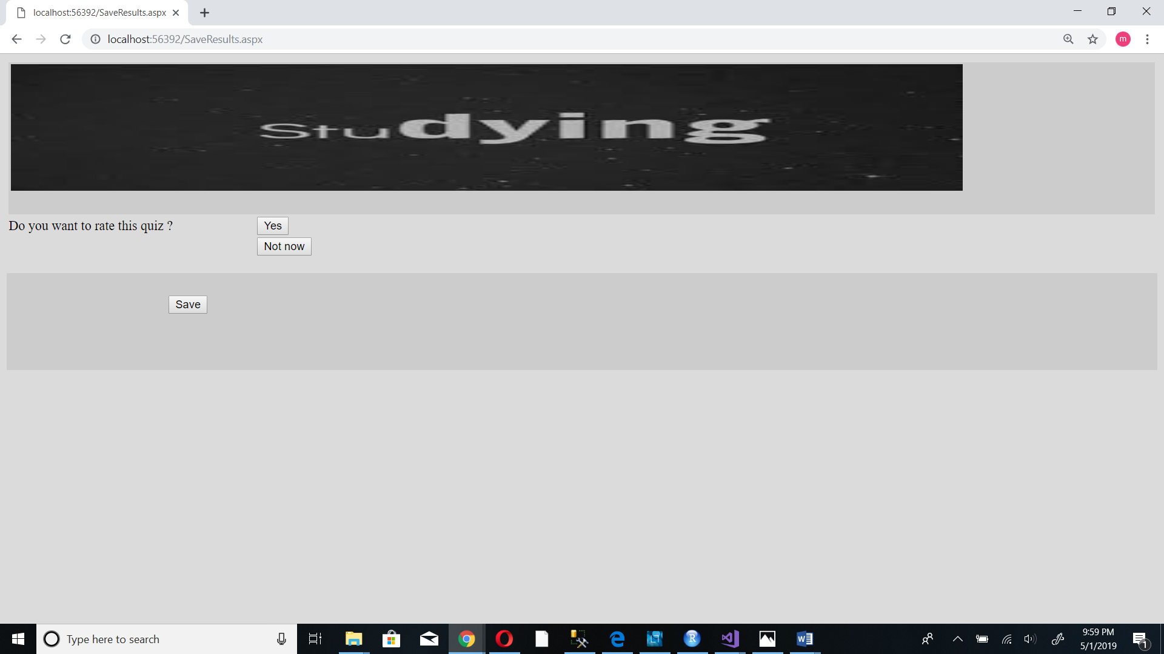

You will be prompted with the question “Do you want to rate this quiz?”

Tap “yes” if you want to rate it now or tap “Not now”

1. Select the rating you want to give and tap the “Save” button

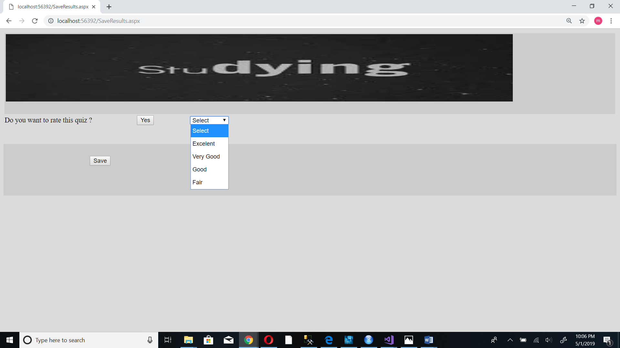

You will be prompted to your homepage

**4.3 See Report Card**

1. From your home page tap “Report card” button

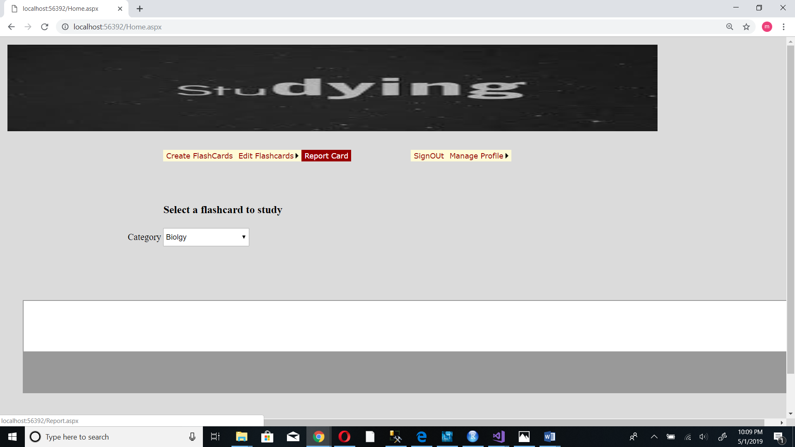

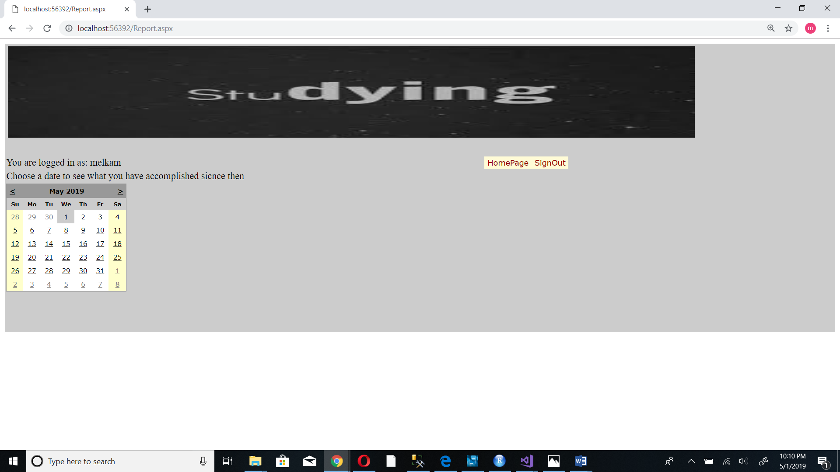

2. Select a date

List of all your results will appear

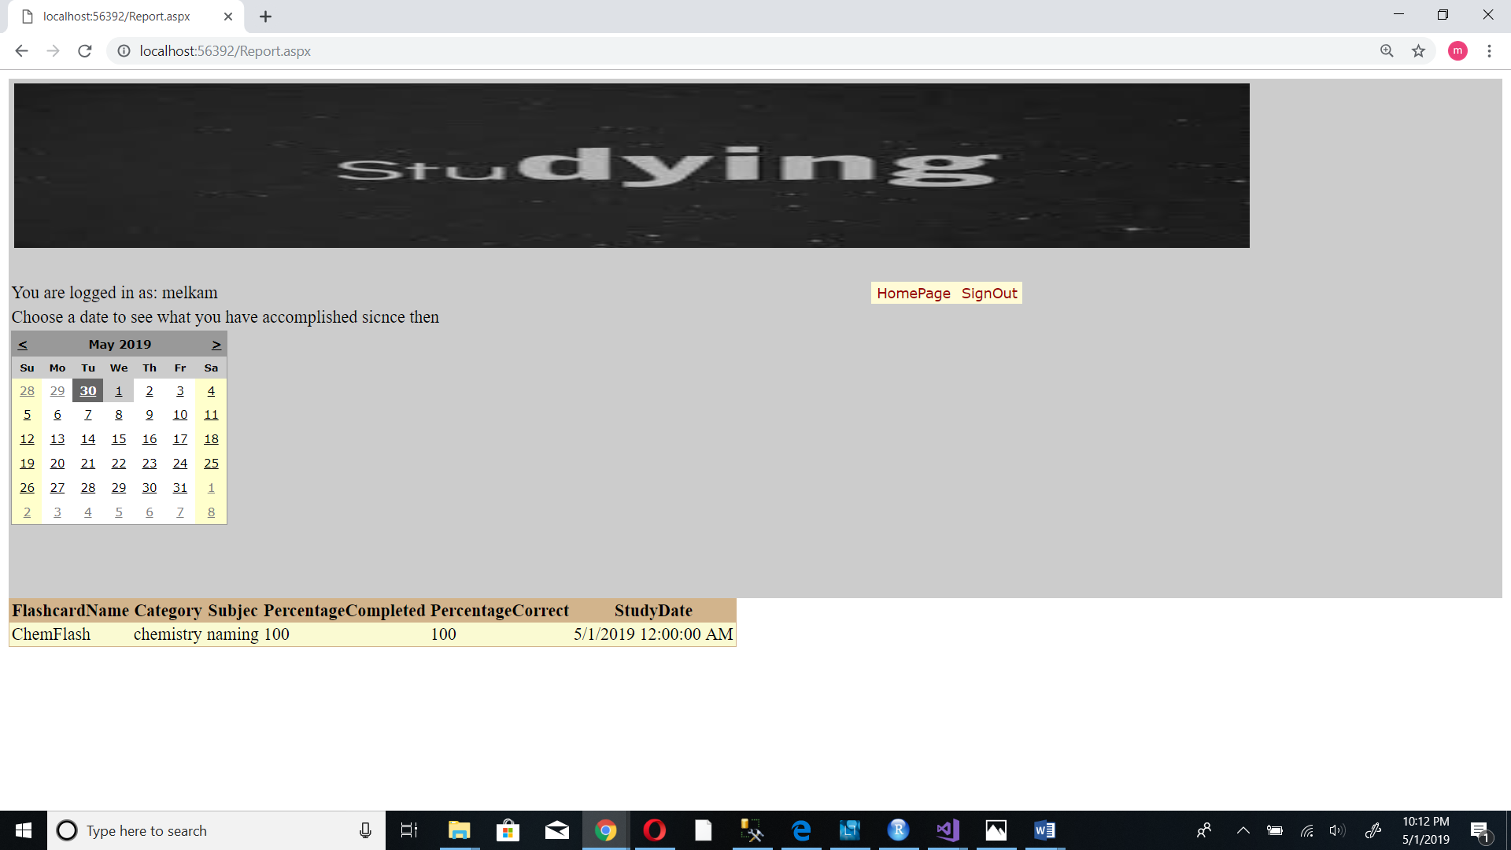

**4.4 Edit Flash card**

**4.4.1 Edit your Flash card**

1. From your home page select “Edit Flash card/ My flash card”

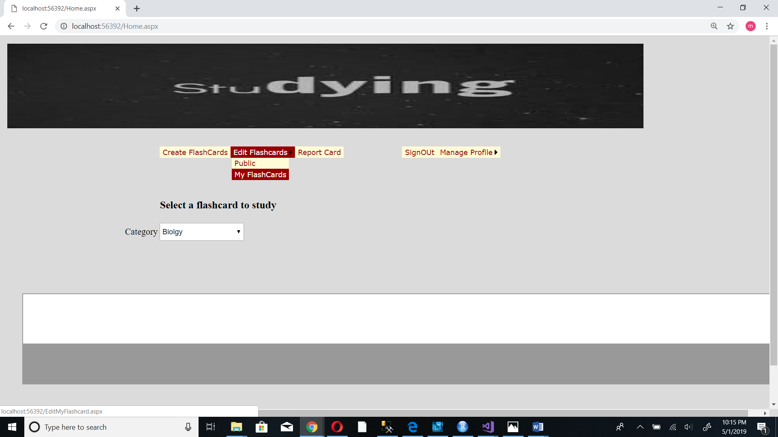

2. Select flash card that you want to edit

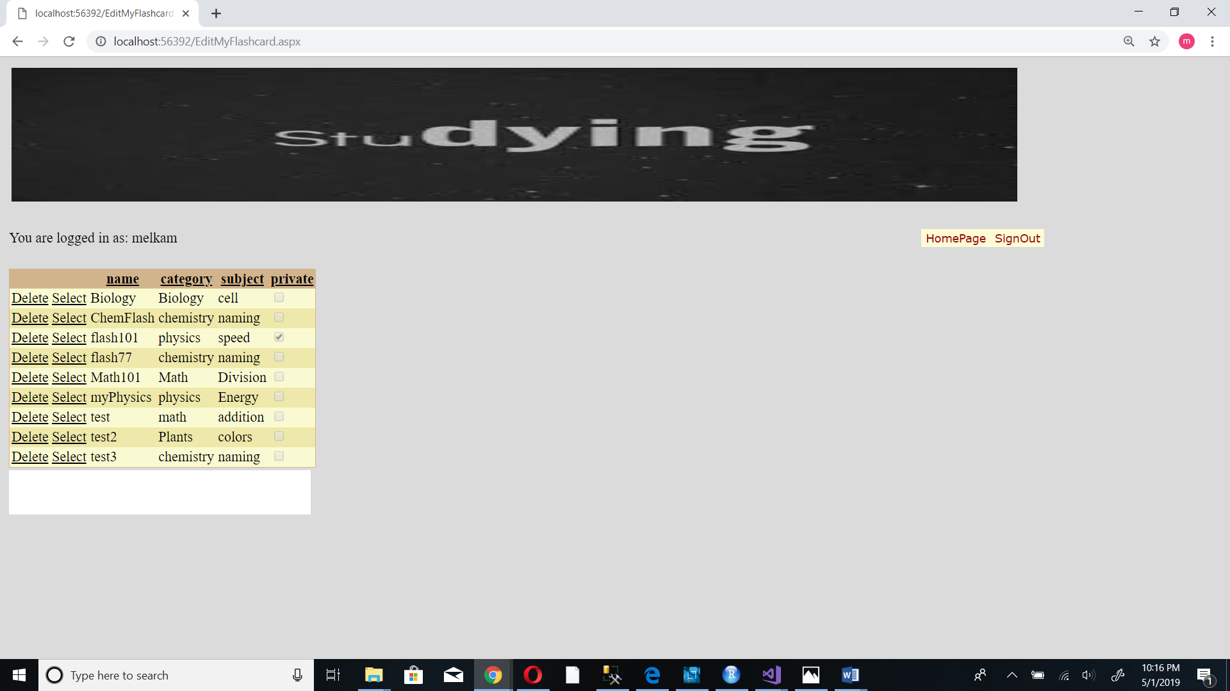

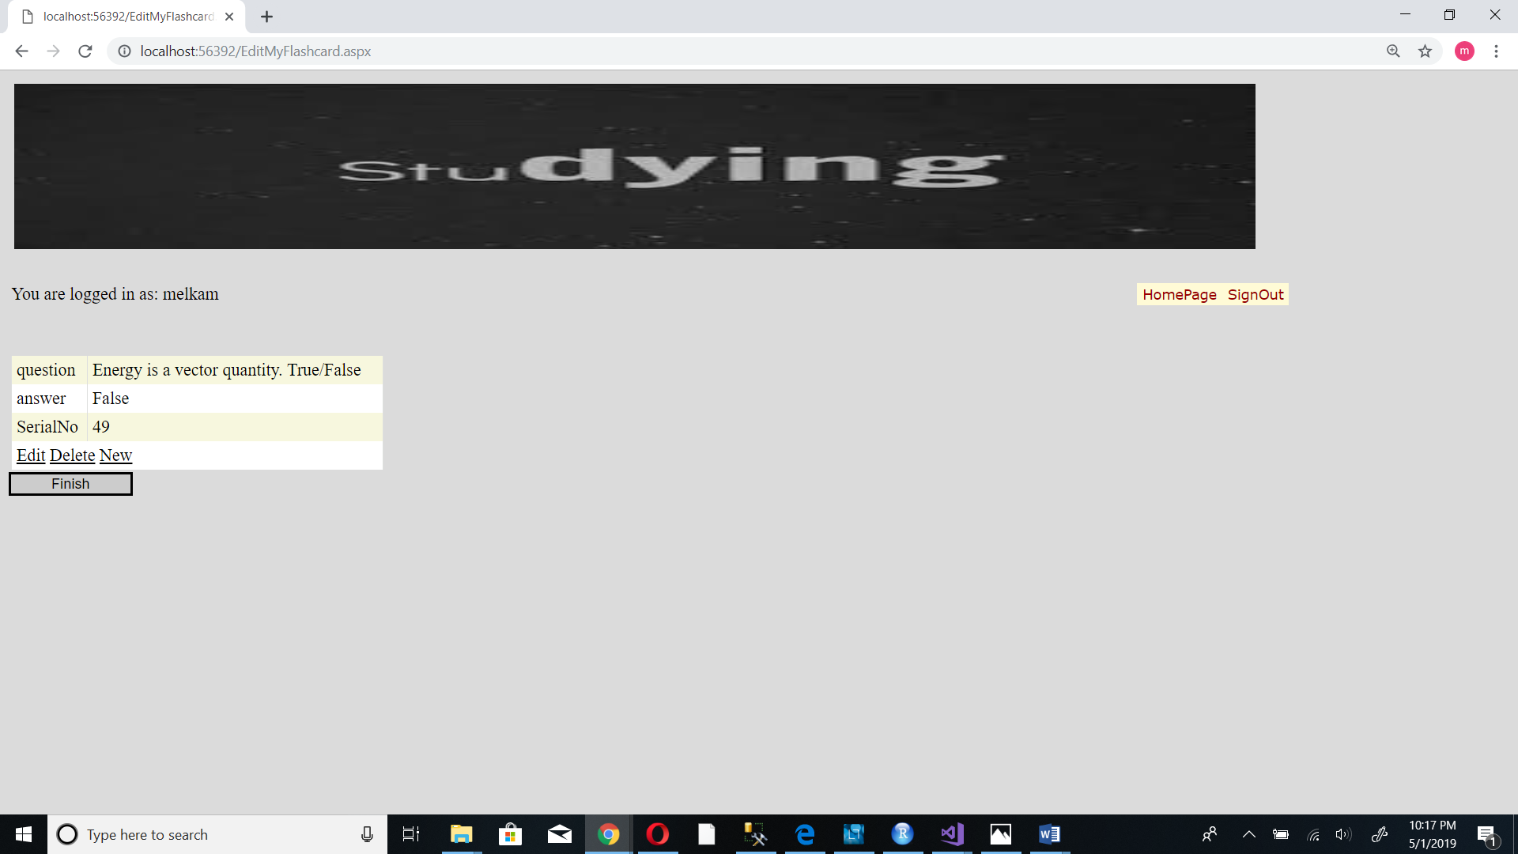

3. You will have the option to “Edit”, “Delete” or create a new question

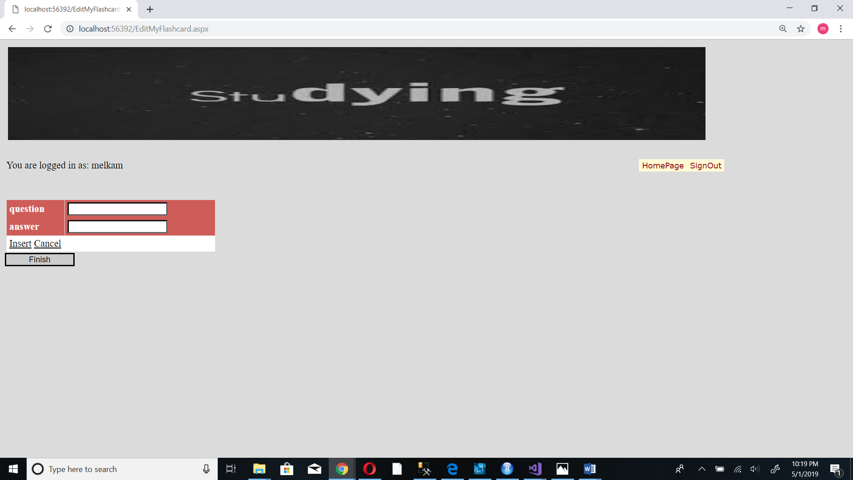

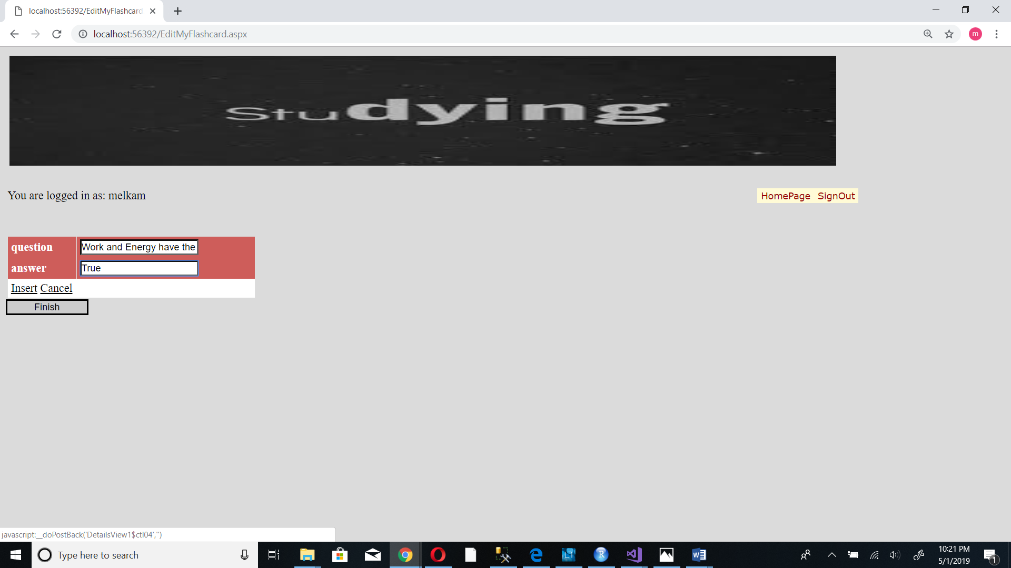

4. Tap the Insert button to add the question

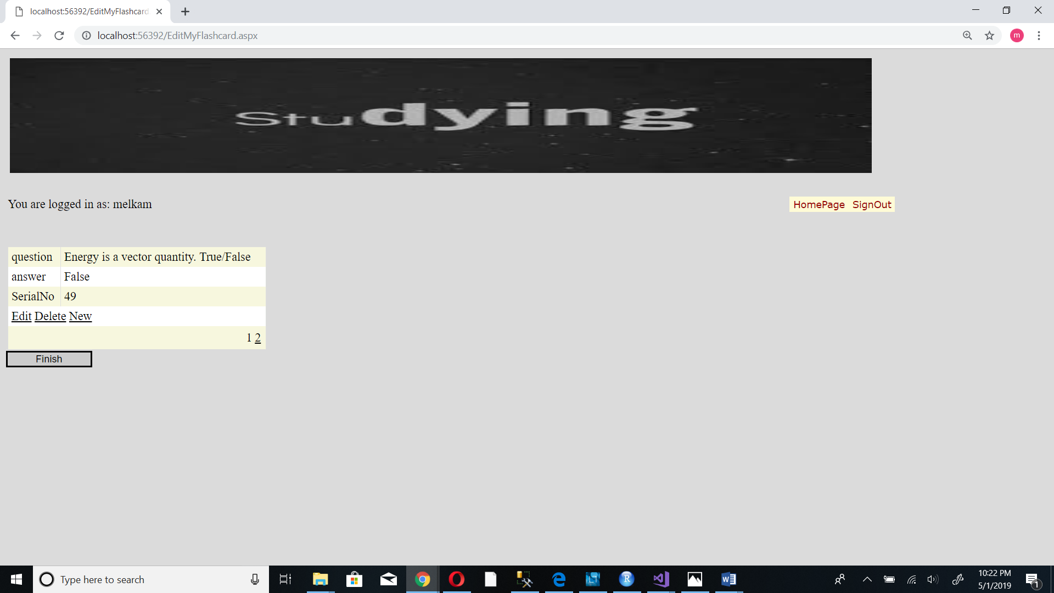

5. Tap the Finish button to finish editing

**4.4.2. Edit public flashcard**

1. From your home page select “Edit Flashcard / public”

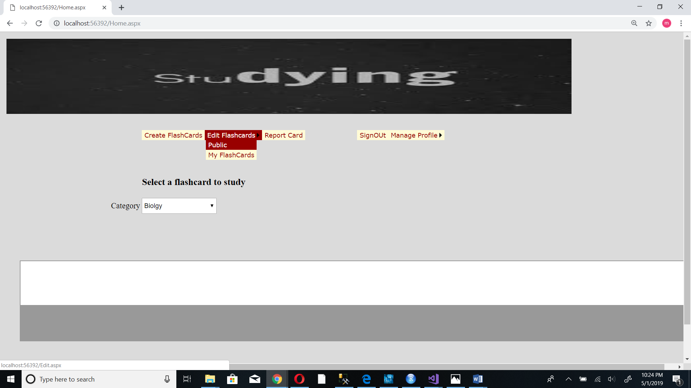

2. Select the flash card that you want to edit

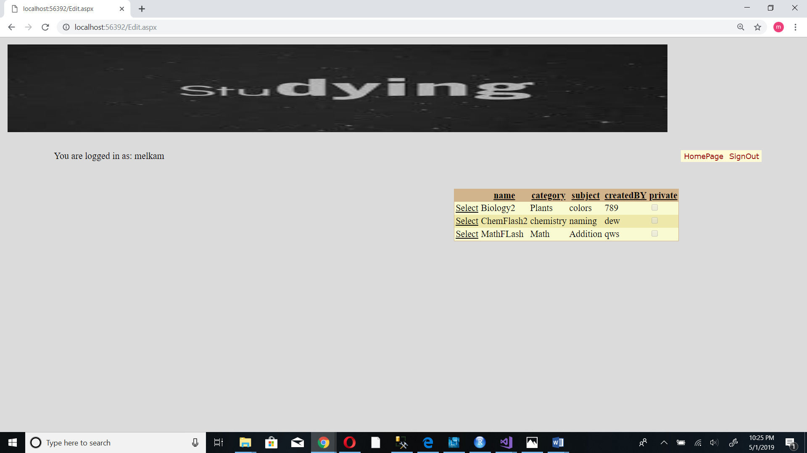

3. Provide all the necessary information

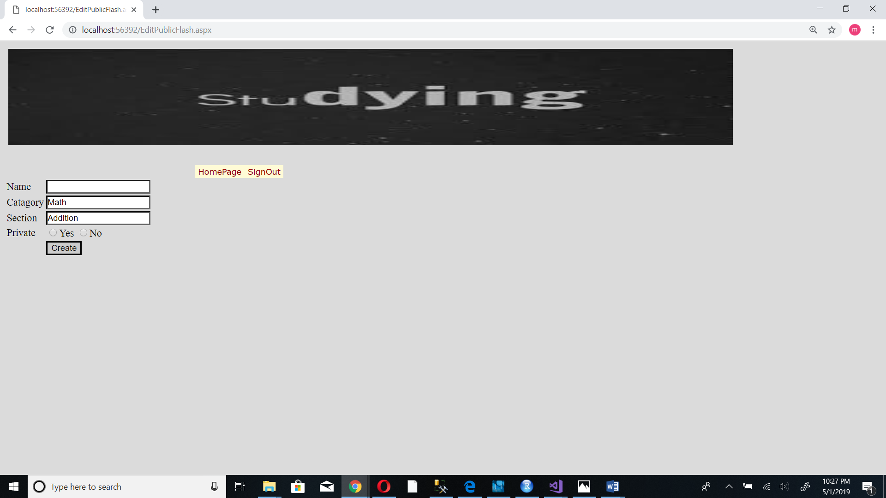

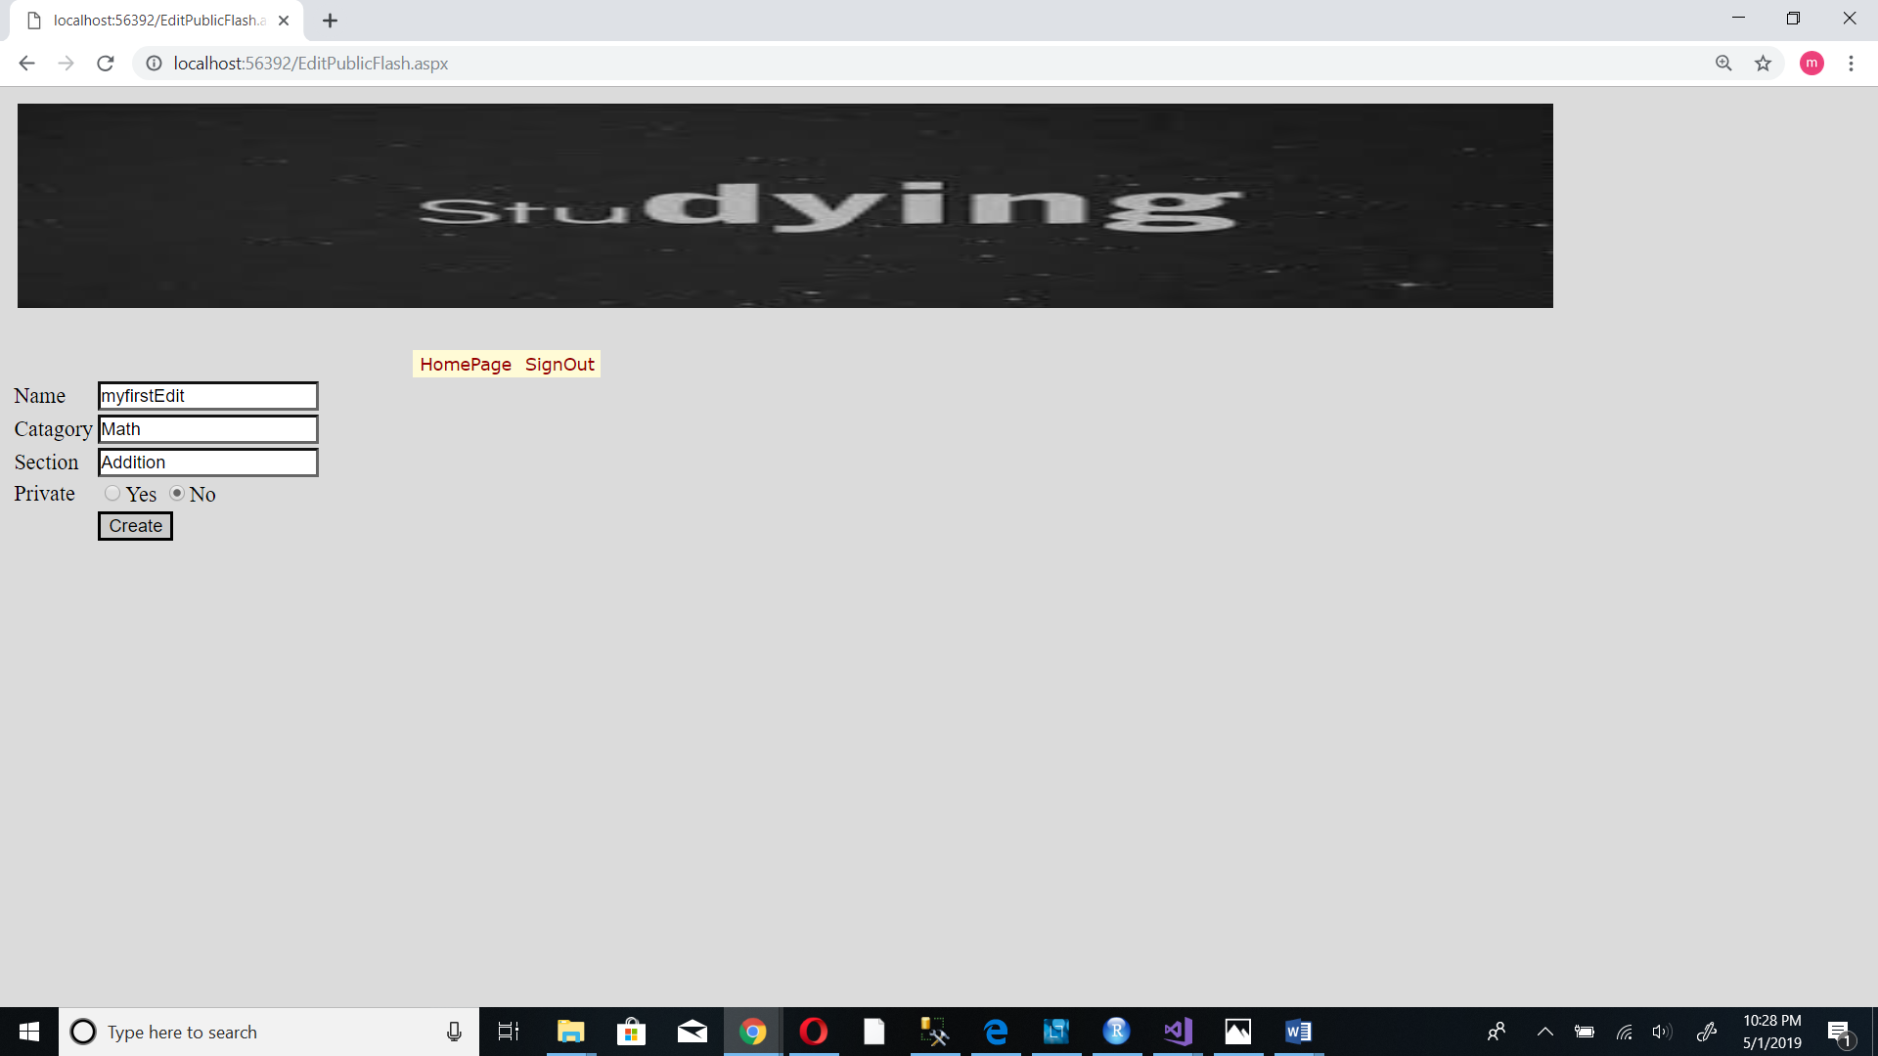

4. Tap the “create” button

**5.. Troubleshooting**

**5.1 Locked account**

When invalid user name is used to login into account, the account will be locked after the third attempt. In this case the user needs to contact the admin to activate their account.

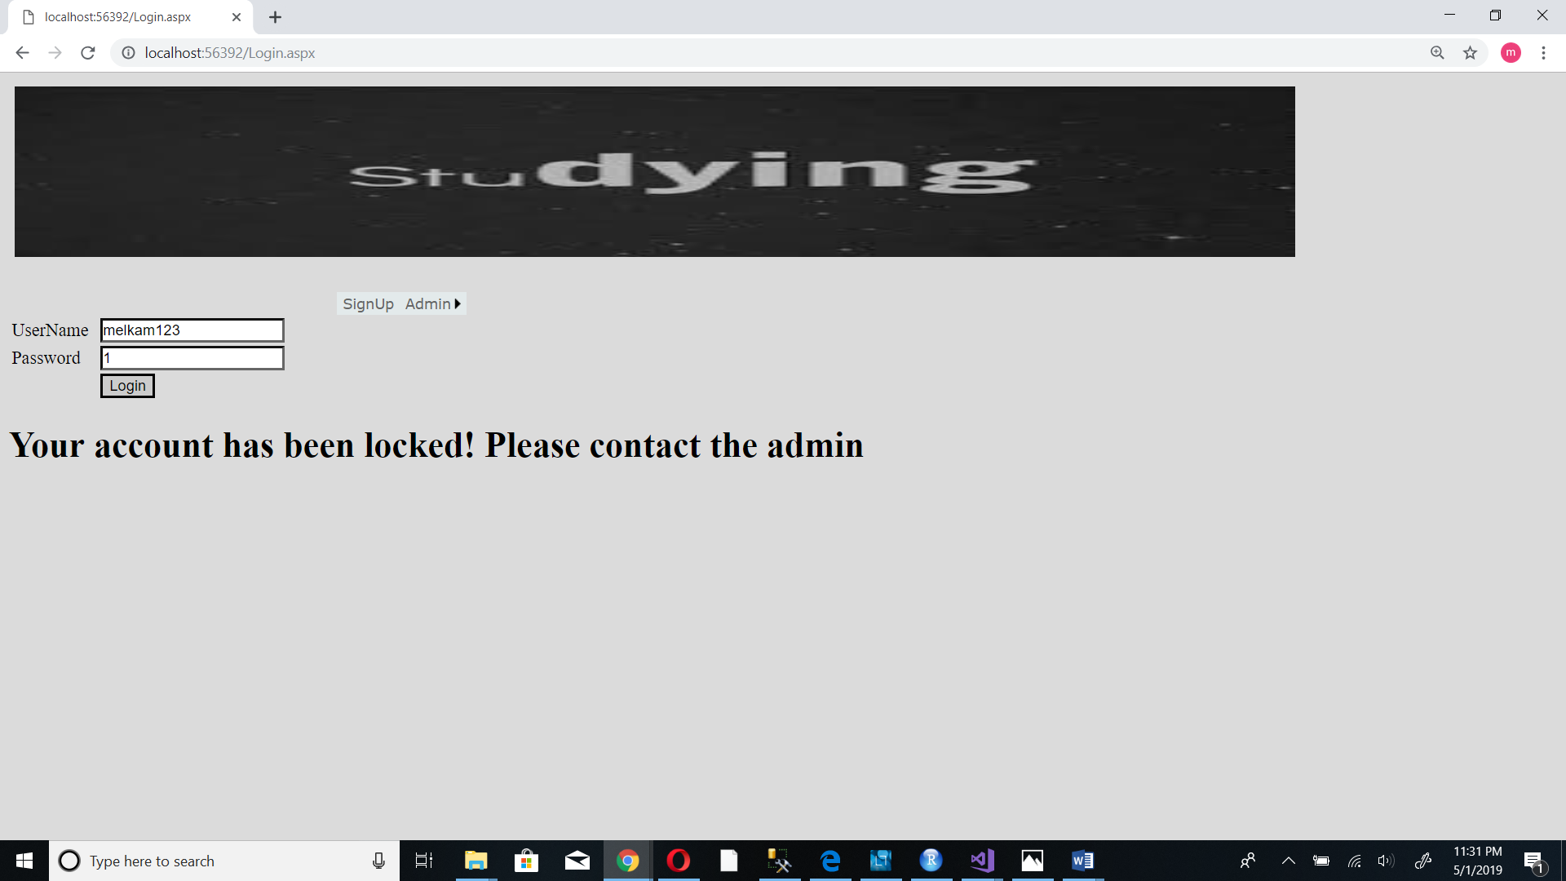

**5.2 Error when creating new flashcard**

When creating a new flashcard if one tries to give a name that already exists. The system will show an error message. A new name which hasn’t been taken should be provided.

